SUMMATIVE ASSESMENT-II

Time- 2.30 H SCIENCE-X Maximum Marks-90

02. SA.II.X.SC.Jan14. Date:4.2.2014

General Instructions:

1. The question paper comprises of Two sections ,**A** and **B .**You are to attempt both the

sections.

1. All questions are compulsory.
2. All questions of Section-**A** and all questions of Section –**B** are to be attempted separately.
3. Questions numbers 1 to 3 in Sections –A are one mark questions. These are to be

answered in one word or in one sentence.

1. Question numbers 4 to 7 in Section-A are two marks questions. These are to be answered in about 30 words each.
2. Question numbers 8 to 19 Sections-A are three marks questions .These are to be answered in about 50 words each.
3. Question numbers 25 to 42 in section –B are multiple choice questions based on practical skills. Each question is one mark question .You are to select one most appropriate response out of the four provided to you.

**SECTION -A**

1.In the following fool chain .15 J of energy was available to tigers. How much energy would have been present in the plants?

Plants Deers Tiger

2. Which of the following are carboxylic acids? Write their structural formulae.

C2H4O2,C2H4O,C2H6O,C3H6O2

3.Give one example of each of renewable sources of energy and non-renewable sources of energy.

4.(i)What happens to the ray of light when it travels from one medium to another both having equal refractive indices?

(ii)State the cause of refraction of light.

5. An element has atomic number 20.

(i)Identify the element.

(ii)Is it a metal or non-metal?

(iii)Is it more reactive than Mg?

(iv)Will it be larger or smaller than K?

6. Disuss the role of fallopian tubes in the female reproductive system.

7. When sunlight is concentrated at a paper placed at the principle focus of a convex lens. What happens to the paper and why?

8.(i)Define dispersion of light.

(ii)Light of two colours’A and ‘B’ pass through a prism.’A’ deviates light more than ‘B’ from its path of incidence .Which colour has the higher speed in the prism?

(iii)Draw a ray diagram to show the path of a light that enters into the glass prism obliquely .Label the angle of incidence and angle of deviation on it?

9.(i)Why does carbon form very large number of compounds?

(ii)Write the chemical equation representing the preparation of ethene from ethanol.

(iii)Give an example of etherification reaction.

10.What do you understand by the term fossil; ?Discuss the importance of fossils in deciding evolutionary relationship.

11.(i)A convex lens is called a converging lens .Explain the reason with the help of a diagram.

(ii)An object of size 5 cm is placed at 25 cm in front of a convex lens of focal length 15 cm .At what distance from the lens should a screen be placed so that a sharp focused image can be obtained? Find the size nature of image formed.

12. Where in period 2 of the modern periodic table do we find:

(i)non-metals,

(ii)elements forming negative ions,

(iii) elements with high melting points,

(iv) elements forming positive ions,

(v)metals,

(vi)elements with low boiling points?

13.In a village ,vultures are found to be dead due to insecticide poisoning after eating dead animals .Vultures are very important for a food chain and their death has a matter of great concern.

(i)What do you learn from the incident of death of vultures?

(ii)What precautions should we take in eating our food?

(iii)What measures can be taken by government to reduce biological magnification?

14.From the given data showing focal length of three convex mirrors,A,B,C, and the respective distance of different from these mirrors, answer the questions given below:

|  |  |  |
| --- | --- | --- |
| S.No. | Object distance (cm) | Focal length (cm) |
| A | 45 | 20 |
| B | 30 | 15 |
| C | 20 | 30 |

(i)In the given positions of object from the mirrors, which mirror will from the diminished image of the object. Draw a ray diagram for the image formation by this mirror.

(ii)Which mirror can e conveniently used as a make –up mirror? Draw a ray diagram to illustrate this function.

15. The following table represents elements A, B, C, D, E, F, G, H, and I in a part of periodic table

|  |  |  |  |  |  |  |  |  |  |
| --- | --- | --- | --- | --- | --- | --- | --- | --- | --- |
| Group /Period | 1 | 2 | 3 to 12 | 13 | 14 | 15 | 16 | 17 | 18 |
| 2 | A |  |  | H |  | B | I |  | C |
| 3 |  | D |  |  | E |  | G |  | F |

Using the above table, answer the following questions:

(i)Which element is metal with valency equal to 2?

(ii)Which element (s) will from ionic compounds?

(iii)Which element is smaller in size among D, E and G and why?

(iv)Name the family to which I and g belong?

(v)Name the element(s) which is/are least reactive.

(vi)Which elements (s) will show covalency equal to 4?

16. What is a dam? List three problems which arise due to construction of a big dam .Suggest a solution to overcome its ill effects.

17. With the help of suitable example, explain natural selection.

18. List any three differences between pollination and fertilisation.

19. Explain the following methods of contraception giving one example of each:

(i)Hormonal Imbalance Method

(ii)Surgical Method

If a woman is using copper-T, will it help in protecting her from sexually transmitted diseases?

20.(i)Name the type of lens used obtain:

(a) an erect, enlarged and virtual image of an object.

(b)an erect, diminished and virtual image of an object.

(ii)Redraw the diagram given below in your answer book and complete the path of ray.

(iii)What is the difference between virtual images produced by concave, plane and convex mirrors?

(iv)What does the negative sing in the value of magnification produced by a mirror indicated about an image?

21. Complete the following reactions:

(a)CH3COOC2H5+NaOH

(b)CH3COOH+NaHCO3

(c)CH4+Cl2 Sunlight

(ii)Write IUPAC names of the following compounds:

(a)CH3CH2COOH (b)CH3CH2Br

(iii)Why are soaps ineffective in hard water?

22. Identify A, B, C, D, and E in the given diagram and write their functions.

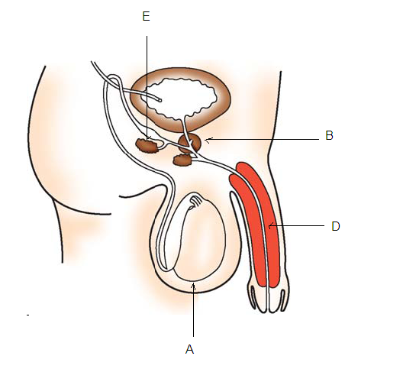S

23.A student finds the text written on the blackboard as blurred and unclear when sitting on the last desk of the classroom.He,however ,sees the text clearly while sitting on the front desk at an approximate distance of 2 m from the blackboard.

(i)Draw the ray diagram to illustrate the formation of image of the text written on blackboard by his eye lens while sitting at the

(a)Last desk (b) front desk.

(ii)Name the defect of vision the student is suffering from .Also, list two causes of this defect.

(iii)Name the kind of lens that would enable him to see clearly while sitting at the last desk .Draw the ray diagram to illustrate how this lens helps him to see clearly.

25. Which of the following pairs of safely symbols you notice on the bottles of commercial acetic acid in laboratory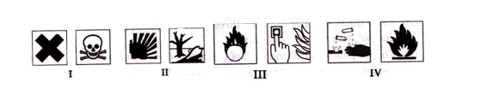?

(a) I (b)II (c) III (d)IV

26.5 mL of acetic acid was added to equal volume of water and the mixture was shaken well for one minute and allowed to settle .The correct representation of the observation made would be as given in the test tube

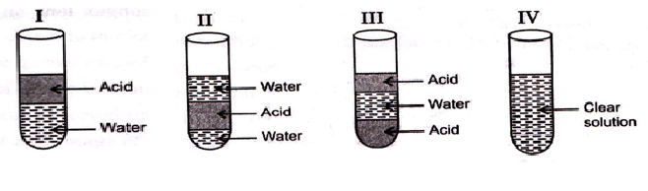

(a)I (b)II (C)III (iv)IV

27.The correct equation involved in removal of hardness of water is

(a)CaCl2 (aq)+Na2CO3(aq) CaCO3(s)+2NaCl(aq)

(b)2NaCl(aq)+K2CO3(aq) Na2CO3(aq)+2KCl(aq)

(c)2KCl(aq)+Na2CO3(aq) K2CO3(aq)+2NaCl(aq)

(d)MgCl2(aq)+Na2SO4(aq) MgSO4(s)+2NaCl(aq)

28. Saponification is

(a)exothermic (b)endothermic (c)etherification (d)neither exothermic nor endothermic.

29. Which of the following is not a fat or oil?

(a)Glyceryl stearate (b) Glycery palmitate

(c)Glyceryl oleate (d) Sodium stearate

30. Which of following has maximum foaming capacity in soft water?

(a)Sodium stearate (b) Sodium lauryl sulpahte

(c)Sodium palmitate (d) Sodium oleate

31.A student determines the focal length of a device ‘X’ by focusing the image of a student objects on a screen placed on the same side as the object .The device ‘X’ is

(a)convex lens (b)convex lens

(c) Concave mirror (d)convex mirror

32. A student suggested the following guidelines to his friend for the experiment on tracing the path of a ray of light passing through a glass prism:

(A) Draw2 the outline of the glass prism at three positions on the drawing sheet.

(B)Draw normals on the same refracting edge of these outlines.

©Draw the incident rays on the three outlines in directions making angles of 300,450 and 600 with the normals drawn.

(D)Fix two pins vertically on each of these incident rays at two points nearly 1 cm apart.

(E)Look for the images of the heads of these pins while fixing two pins from the other refracting side of the prism to get the refracted rays.

When these guidelines were shown to his teacher ,the teacher corrected and modified the guideline labeled as:

(a) (A,B) (b) (A,C) (c)(B,C) (d) (D,E)

33. The following figure shows the formation on an image by a convex lens on the white screen:

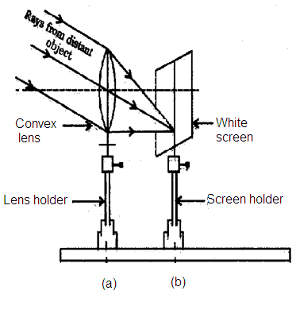

The distance between the points P and Q gives the

(a)Radius of curvature of the lens (b) Twice the focal length of the lens

(c) focal length of the lens (d)aperture of the lens.

34. A student is asked to label his diagram made as observation on tracing the path of light ray through glass slab as follows:

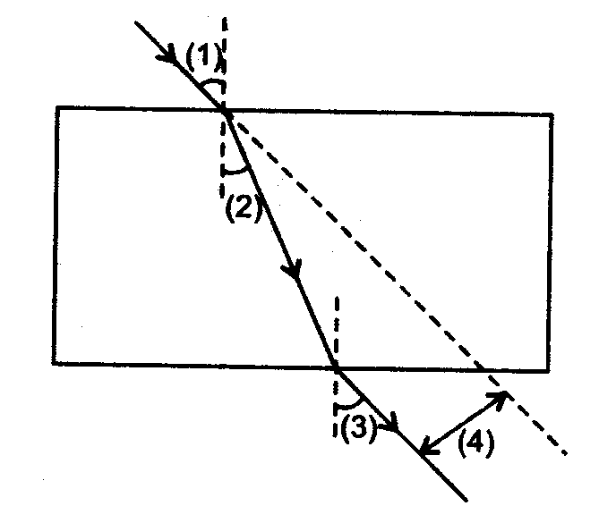

The correct sequence of labeling and lateral displacement respectively is,

(a)(1),(2),(3),and(4) (b)(3),(4),(1)and(2)

(c)(1),(3),2() and(4) (d)(3),(2),(4) and (1)

35.A teacher asked three students to wire one precaution each regarding the experiment on tracing the path of light ray through glass slab. First ,second and third student wrote down following precaution ,respectively:

1. While tracing emergent ray, we should see heads of pins.

2. One eye should be kept closed, while tracing emergent ray.

3. Glass slab should have parallel edges.

The correct statements are of

(a)1 and 2 (b) 2 and 3 (c) 1 and 3 (d) All the three

36.To find the distance for varying object distances in case of convex lens and draw the corresponding ray diagrams to find nature of image formed ,a student observed that when the object is moved from infinity towards the focus of the convex lens,the

A. image moves away from the focus.

B.size image increases gradually.

C.object and image of same size is never obtained.

Which of the above statements in his observation is incorrect?

(a)A (b)B (c)C (d) D

37.In which of the following diagrams the labeling budding in yeast is done correctly?

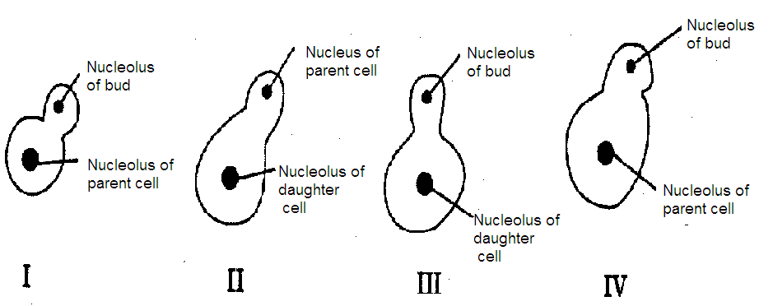

(a)I (b) II (c) III (d) IV

38.From the given information ,identify the mode of reproduction (X).

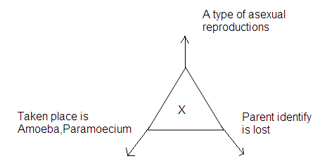

(a) Budding (b)Binary fission (C)Fragmentation (d)Regeneration

39.Which of the following statement is correct?

(a)Homologous organs are structurally same.

(b)Analogous organs are structurally same.

(c)Homologous organs are functionally same.

(d)Analogous organs are functionally not same.

40. Analogous pair of a sweet potato is

(a)Onion (b) Ginger (c) Potato (d) All of these

41. In the adjoining figure of dicot seed correct labeling of parts A, B, C and D is

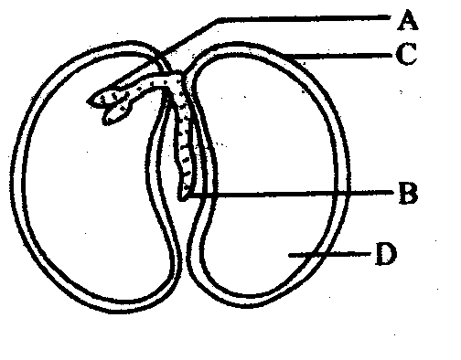

(a)Plumule, radical, cotyledon, seed coat

(b)Plumule, radical, seed coat, cotyledon

(c) Radical, plumule, seed coat, cotyledon

(d)radical ,plumule,cotyledon ,seed coat

42. The part of the seed which provides food to developing seedling is

(a) hypocotyls (b)radical (c) epicotyls (d)cotyledon